

***CSS Essentials***

**Assignments**

|  |  |
| --- | --- |
| Document Code | 25e-BM/HR/HDCV/FSOFT |
| Version | 1.1 |
| Effective Date | 20/11/2012 |

**Hanoi, 04/2019**

RECORD OF CHANGES

|  |  |  |  |  |  |
| --- | --- | --- | --- | --- | --- |
| No | Effective Date | Change Description | Reason | Reviewer | Approver |
|  | 25/Jun/2018 | Create a new Lab | Create new | DieuNT1 | VinhNV |
|  | 01/May/2019 | Update Fsoft Template | Update | DieuNT1 | VinhNV |
|  |  |  |  |  |  |
|  |  |  |  |  |  |
|  |  |  |  |  |  |
|  |  |  |  |  |  |
|  |  |  |  |  |  |
|  |  |  |  |  |  |
|  |  |  |  |  |  |
|  |  |  |  |  |  |

Contents

Unit 12 – CSS Layout 4

Objectives: 4

Project Structure 4

Problem 1: 4

Problem 2: 4

Problem 2: 5

|  |  |
| --- | --- |
|  | **CODE: CSS-E.M.A1301**  **TYPE: Medium**  **LOC: N/A**  **DURATION: 60 MINUTES** |

# Unit 13 – CSS Layout

Objectives:

* Working with the CSS column-count, column-width, column-gap, column-span and column-rule properties and values

Project Structure

* A project called **CSS-E.M.A1301** (this will be your root folder) is provided to you
* Put your work for each problem in corresponding folder inside root folder

Problem 1:

In this task you need to create three columns, with a 50px gap between each column.

Expected output:

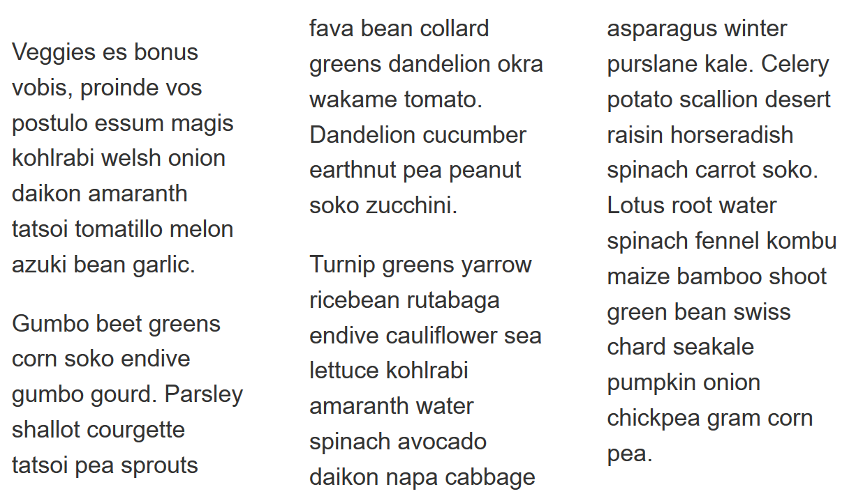

Problem 2:

In this problem, create columns which have a minimum width of 200px.

Then, add a 5px, grey rule between each column, ensuring there is 10px of space between the edge of the rule and the column content.

Expected output:

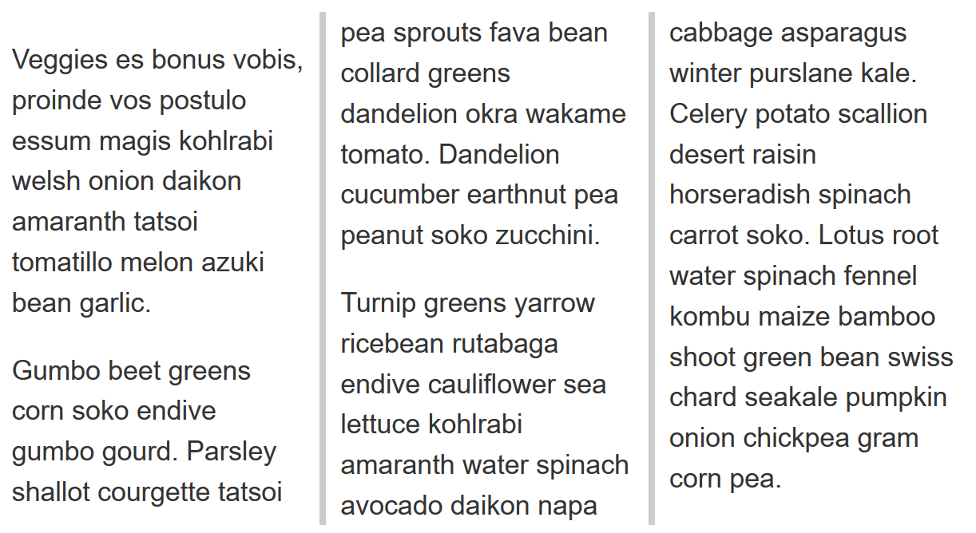

Problem 2:

Cause the element containing the heading and subheading to span across all columns so it looks like the image.

Expected output:

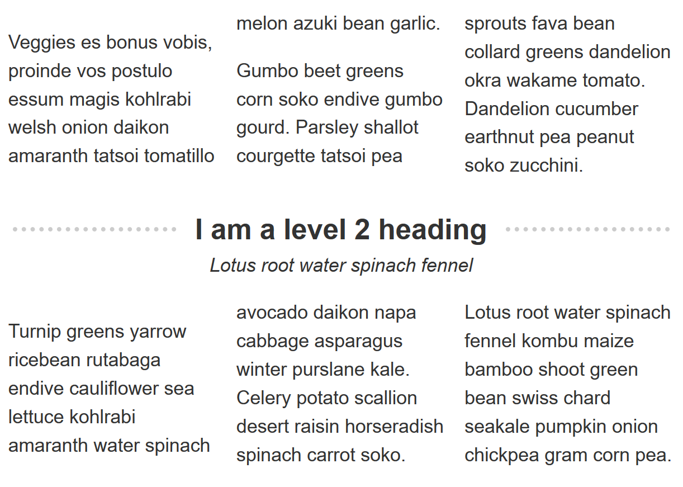

**-- THE END --**